ARRAY PART-2
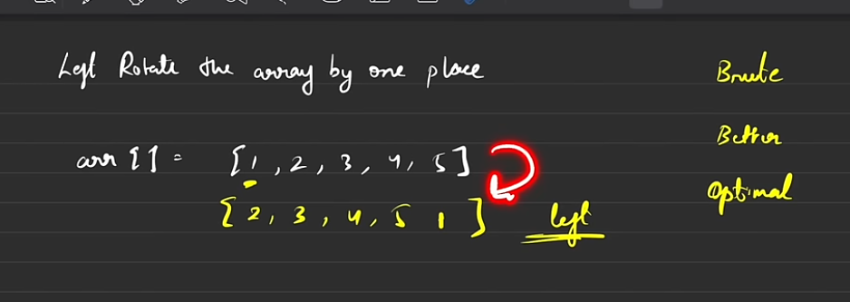
Q-1 Left Rotating an array by one place (Meaning shifting of each element to left by 1 place)
->This is a simple question so we can directly move to the optimal solution rather than investing time on the brute and optimal soltuions and we would not be using any new array for rotation rather we’ll do it in the same array. Since, we have to only shift by 1 place thus it makes it very simple and we’ll be increasing the difficult afterwards

